Lab Report Walkthrough – 4.7.1

Title: Tracing Network Path and Investigating ISP Routing (Physical Layer Exploration-Packet Tracer)

Objective
The objective of this lab was to:
- Examine local IP addressing information
- Identify private and public IPv4 addresses
- Determine the default gateway
- Use the tracert command to trace packet paths
- Identify ISP Point of Presence (POP)
- Analyze routing across multiple networks
- Understand geolocation limitations
- Investigate Internet2 backbone routing

Part 1: Examine Local IP Addressing Information
In Part 1, we examined the IP configuration of the Home PC inside Packet Tracer.

Step 1: Identify IPv4 Address
From Home PC → Desktop → Command Prompt
Command used: ipconfig
Observed Results:
- IPv4 Address: 192.168.0.75
- Subnet Mask: 255.255.255.0
- Default Gateway: 192.168.0.1
The IPv4 address 192.168.0.75 is a private IPv4 address assigned within the home network.
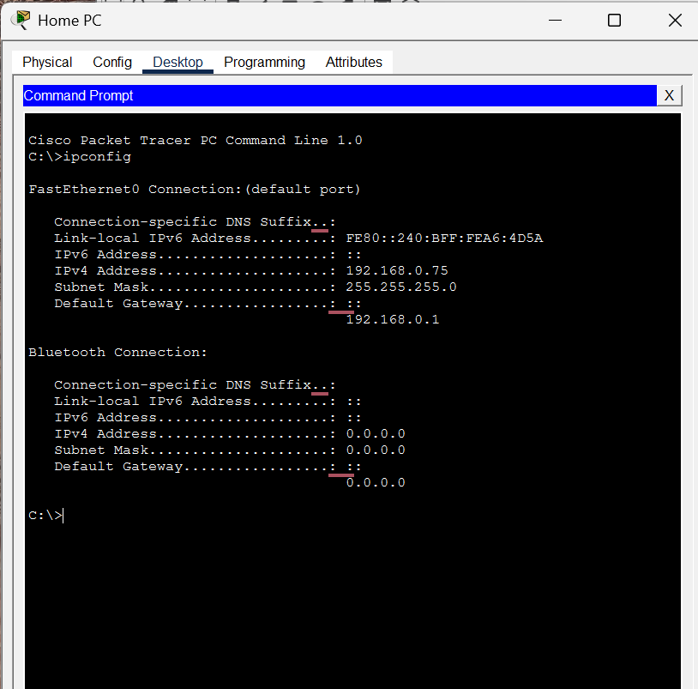

Step 2: Identify Router IPv4 Address
The default gateway shown in ipconfig is: 192.168.0.1
This represents the Home Router IP address.

Step 3: Identify Public IPv4 Address
From Home PC → Desktop → Web Browser
URL entered: http://www.tellmemyip.com
Observed Results:
- Public IPv4 Address: 10.70.93.27
- ISP: Comcast Cable Communications
- Location: Pacific Grove, California, USA
This public IP address is used for communication over the internet.
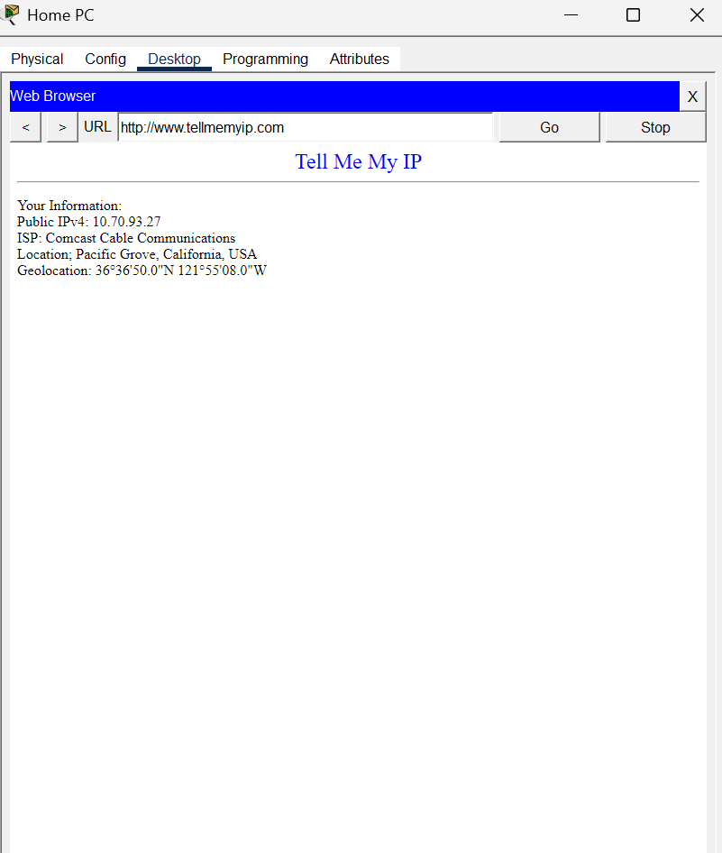

Step 4: Examine Network Connections
- The Home PC is connected to the Home Router using a wired Ethernet connection.
- The Home Router connects to the ISP using a wired cable connection.

Conclusion – Part 1
IP addressing information was successfully identified and verified. The relationship between private addressing and ISP-provided public addressing was clearly observed.

Part 2: Trace the Path Between Source and Destination
In Part 2, we used the tracert command to analyze how packets travel from the Home PC to www.hawaii.edu.

Step 1: Perform Traceroute
From Command Prompt: tracert www.hawaii.edu
Observed Output (Important Hops):
Hop 1 – 192.168.0.1
Hop 2 – 10.120.89.61
Hop 3 – 10.110.178.133
Hop 4 – 10.139.198.129
Hop 9 – 10.110.32.246
Hop 10 – 172.16.69.141
Hop 12 – 172.16.47.134
Each hop represents a router forwarding the packet toward the destination.
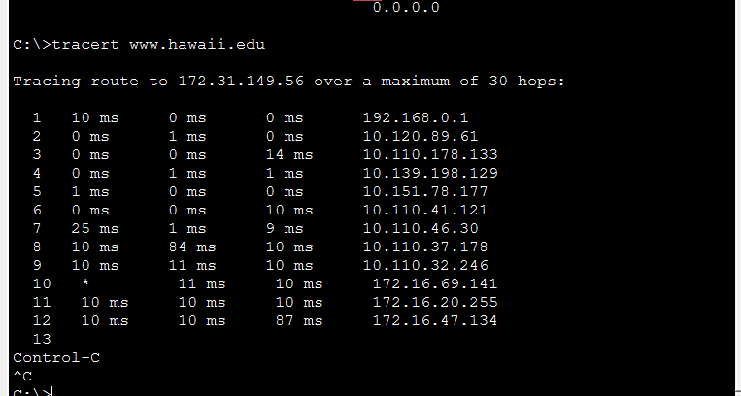
Step 2: Identify the ISP POP
The second hop was: 10.120.89.61
This represents the ISP’s Point of Presence (POP). It is the first router outside the local home network.

Step 3: ISP POP Information
ISP POP | Your Results
2nd Hop IPv4 Address | 10.120.89.61
ISP | Comcast Cable Communications
City | Monterey
Region | California
Country | USA
Note: Since the IPv4 address is private, its exact physical location cannot be determined using public geolocation services.

Step 4: Why Geolocation is Not Always Accurate?
IP geolocation is not always reliable because ISPs may register IP address blocks in a centralized administrative location rather than the actual router’s physical location. Therefore, geolocation data may not represent the real path of packets.

Step 5: Investigate the Local ISP Network
The 3rd and 4th hops were:
- 3rd Hop IPv4 Address: 10.110.178.133
- 4th Hop IPv4 Address: 10.139.198.129
These routers belong to Comcast’s internal network.
Domain names observed in traceroute include references to:
- Monterey, California
- Santa Clara, California
- Sunnyvale, California
- San Jose (Great Oaks), California
This indicates routing within the San Francisco Bay Area.

Step 6: Domain Name Analysis
The traceroute output includes domain names such as: -
- monterey.ca.sfba.comcast.net
- santaclara.ca.sfba.comcast.net
- sunnyvale.ca.ibone.comcast.net
- greatoaks.ca.ibone.comcast.net
These domain names indicate geographic routing and show that traffic is traveling through Comcast routers in California before being handed to another ISP.
The following information was gathered by clicking each building and examining router interfaces in Physical Mode:
Hop | Domain Name | Interface | IPv4 Address
5 | santaclara.ca.sfba.comcast.net | GigabitEthernet0/0 | 10.110.178.133
6 | sunnyvale.ca.ibone.comcast.net | GigabitEthernet0/1 | 10.139.198.129
7 | greatoaks.ca.ibone.comcast.net | GigabitEthernet0/0 | 10.110.32.246
8 | losangeles.ca.ibone.comcast.net | GigabitEthernet0/2 | 172.16.69.141
9 | losa.net.internet2.edu | Serial0/0/0 | 172.16.47.134

Step 7: Link Between Comcast and Internet2
The final Comcast router appears at hop 9: 10.110.32.246
After this hop, traffic enters the Internet2 network: Hop 10 – 172.16.69.141
This indicates that packets are forwarded from Comcast to Internet2.
Step 8: What is Internet2?
Internet2 is a high-speed research and education network operated by a consortium of universities and research institutions. It provides an advanced networking infrastructure separate from the commercial internet.
Step 9: Link to Los Angeles
The domain: losa.net.internet2.edu
Indicates that traffic passes through Los Angeles before crossing the Pacific Ocean.

Step 10: Link Across the Pacific Ocean
A significant increase in round-trip time was observed:
- From approximately 24 ms
- To approximately 85 ms
This large increase indicates long-distance transmission, consistent with packets traveling across the Pacific Ocean to Hawaii.

Conclusion
This lab demonstrated how packets travel from a local home network through an ISP’s internal routing infrastructure, across backbone networks such as Internet2, and over international submarine cable links.
The traceroute command provided detailed insight into: -
- Local gateway routing
- ISP Point of Presence (POP) structure
- Regional backbone routing
- Inter-ISP handoff
- Long-distance transmission characteristics
The objectives of the lab were successfully achieved.

